How it all begin

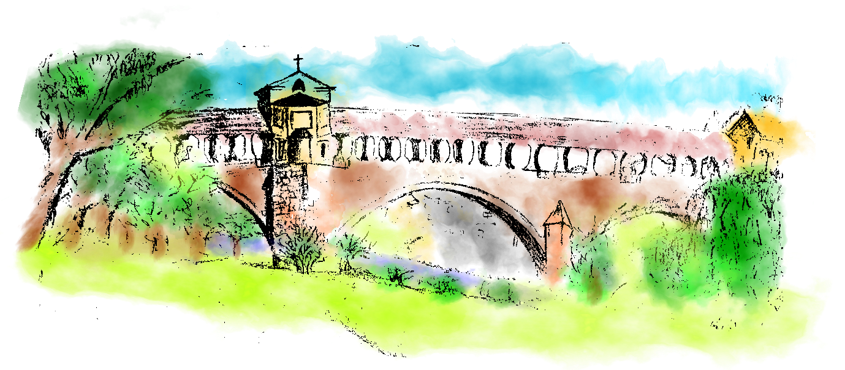

“We enjoy traveling and discovering new places”

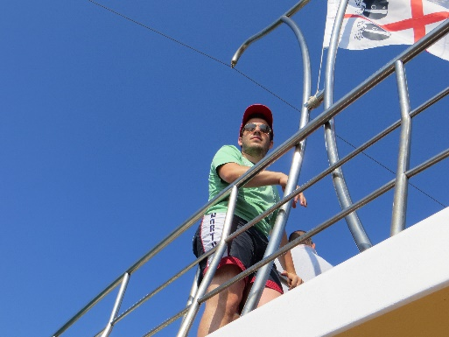 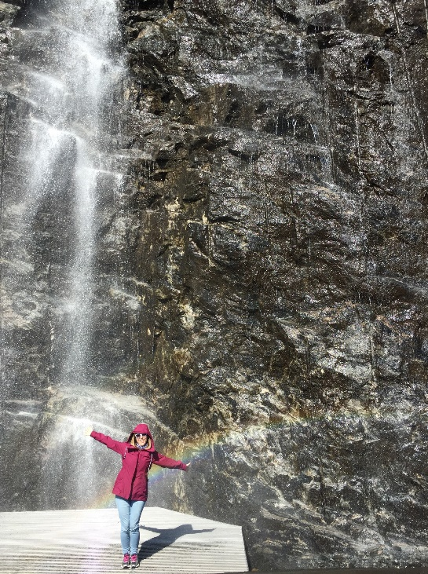

“We love food and wine (of course…we are Italians!)”

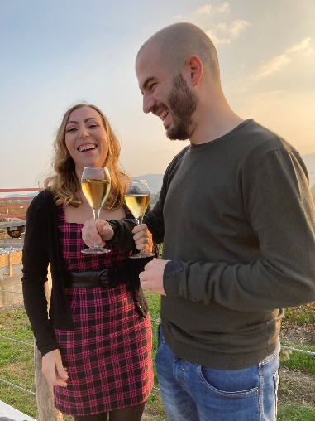

Viola and Gabriele met at the students’ residence in Pavia, where they both attended university, while Viola and her friends were preparing pizza dough for dinner. Starting from a slice of pizza, their friendship transformed into something more. Ten years passed in a blink of an eye and now they are finally ready to tie the knot and celebrate with you their most beautiful day.